Sam McDowell

7/3/2020

Lab 3.3

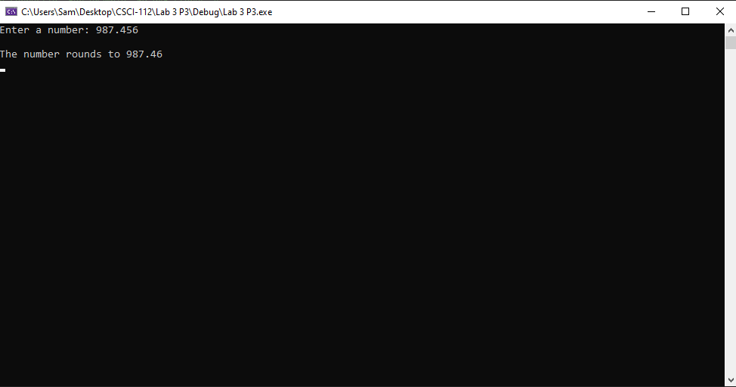

# Transcription:

Enter a number: 987.456

The number rounds to 987.46